

**Tribhuvan University**

**Faculty of Management**

**AN**

**INTERNSHIP REPORT**

**ON**

**“Junior Java Developer Internship at Next Step”**

**Submitted to Department of Information Technology**

**By**

**Sona Bhandari**

**TU Roll No: 9535/18**

**TU Registration No: 7-2-1014-16-2018**

**NIST BANEPA**

**August 2023**

**Under the Supervision of**

**Mr. Samish Shrestha**

Declaration of Originality

I hereby declare that the internship report entitled “**Junior Java Developer Internship at Next Step”** submitted to Office of the Dean, Faculty of Management , Tribhuvan University, Banepa is my original work accomplished under the supervision of **Mr. Samish Shrestha** for the fulfillment of the requirement for the Bachelor Information Management (BIM). This work is an independent work and any help taken from the other people has been mentioned in acknowledgment.

**Sona Bhandari , VIII Semester**



Supervisor’s Recommendation

I hereby recommend that this internship report prepared under my supervision by **SONA BHANDARI** entitled “ **JUNIOR JAVA DEVELOPER AT NEXT STEP**” in partial fulfillment of the requirements for the degree of Bachelor in Information Management is recommended for the final evaluation.

_________________________

Mr.Samish Shrestha

SUPERVISOR

Instructor

Department Of Information Technology, Nist College

Banepa-9, Nayabasti Nala, Kavrepalanchok

Mentor’s Recommendation

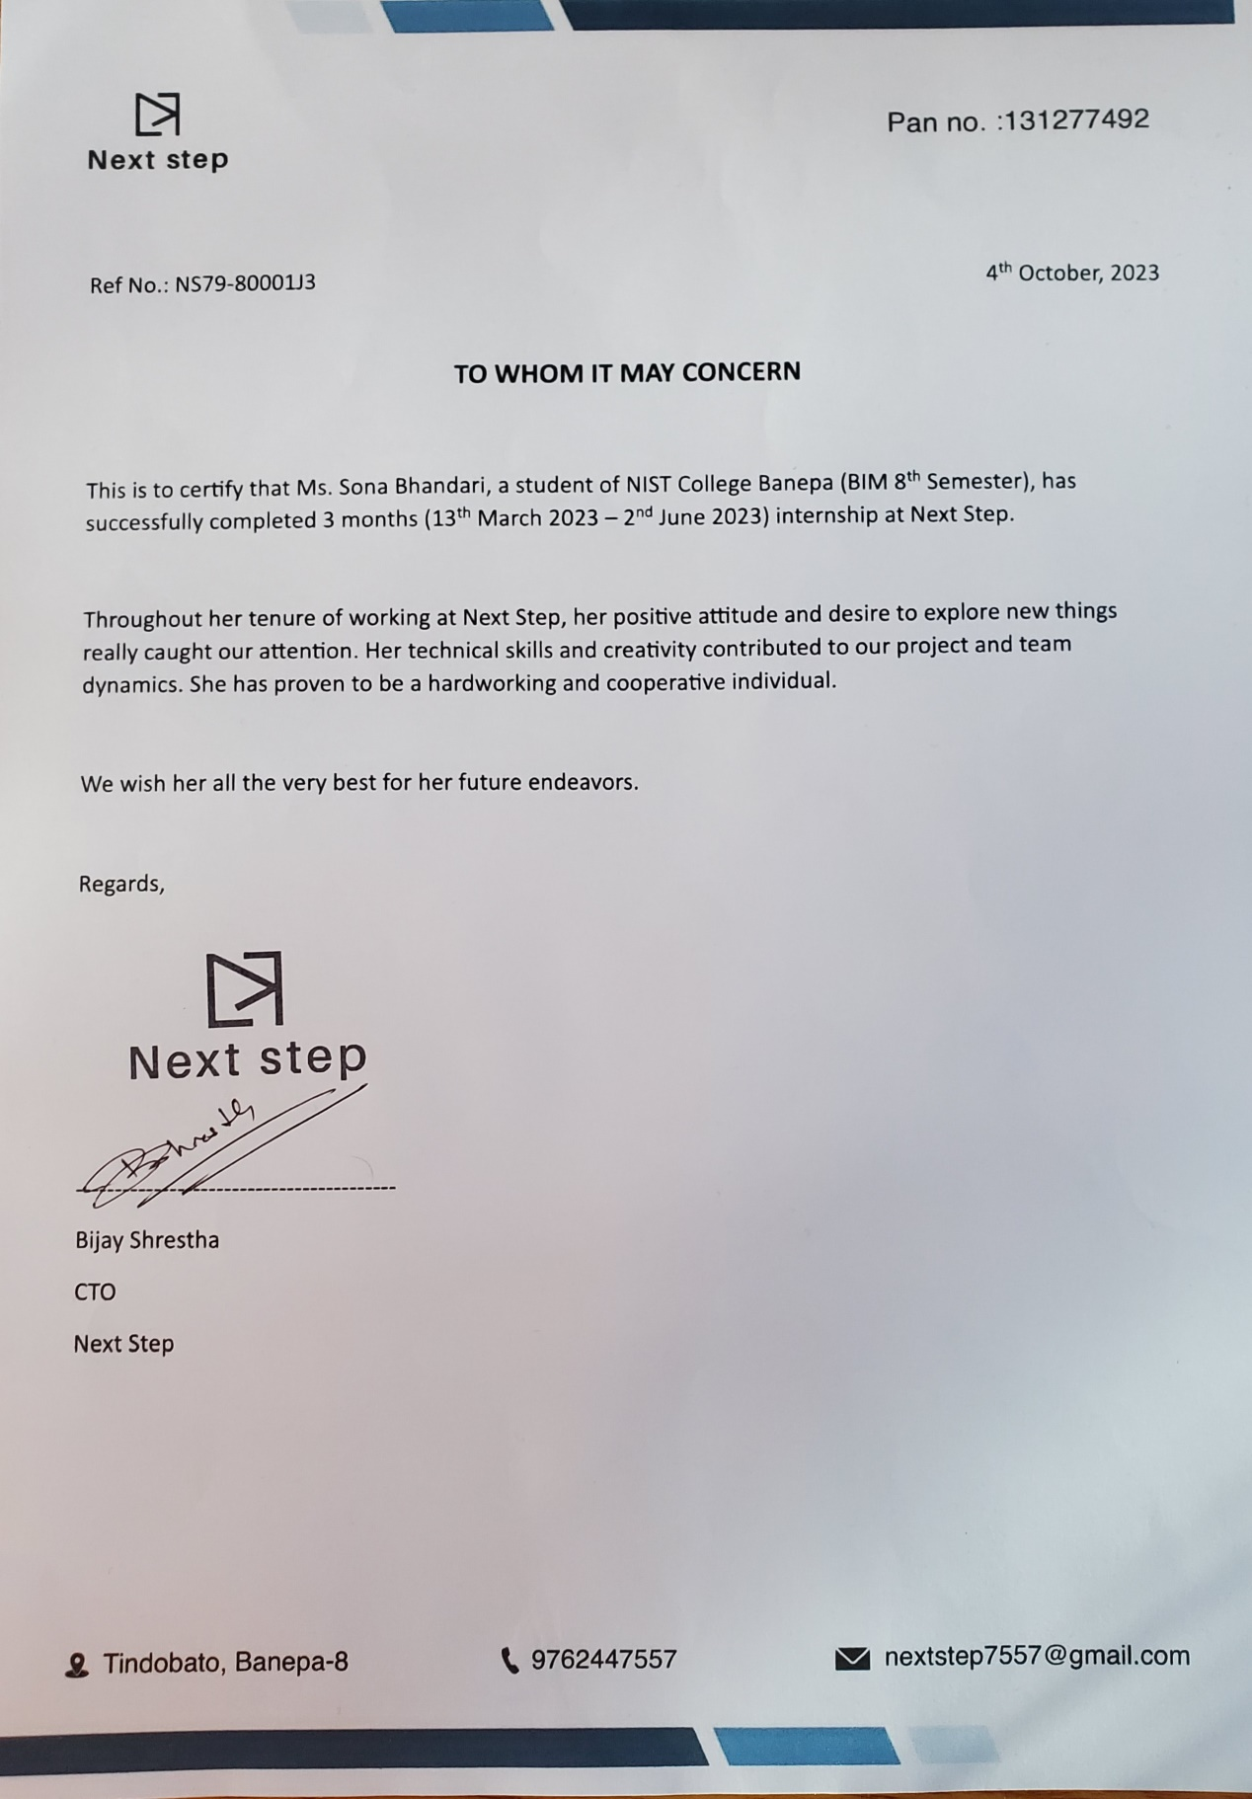

Letter of Approval

This is to certify that this report prepared by **Sona Bhandari** entitled “**JUNIOR JAVA DEVELOPER AT NEXT STEP**” in partial fulfillment of the requirements for the degree of Bachelor in Information Management has been evaluated. In our opinion it is satisfactory in the scope and quality as a project for the required degree.

|  |  |
| --- | --- |
| _________________________  **Mr. Samish Shrestha**  Supervisor  Instructor, Department Of Information Technology, Nist Banepa  Banepa-9,NayabastiNala, Kavrepalanchok | _________________________  **Mr. Yuba Raj Neupane**  Internal Examiner  Department Of Information Technology, Nist Banepa  Banepa-9,NayabastiNala, Kavrepalanchok |

ACKNOWLEDGEMENT

I would like to express my sincere thanks to the Department of Information Technology, Nist College for providing me with this opportunity to explore my thoughts, curiosity and interest in the field of computer science through a Final Year Internship on " **Junior Java Developer** ".

I am glad to take this opportunity to express my sincere gratitude and sincere thanks to our highly respected and esteemed guide **Mr.Samish Shrestha**, Nist College, for his valuable guidance, suggestion, encouragement, critical comment and help for completing this work. His constant support and motivation always encouraged me. My thanks to him will always be counted.

I would like to express my deepest sense of gratitude to my highly respected and esteemed mentor **Mr. Bijay Shrestha,** CTO **,Next Step.** for providing me a golden opportunity for completing my internship at their reputed organization. I would also like to thank Next Step for providing a wonderful and friendly environment to work in. Their useful suggestions for this whole work and cooperative behavior are sincerely acknowledged.

In addition, I extend my sincere thanks to my friends, seniors and guardians for their direct/indirect contribution in this project and helping me to bring this project into existence. I will be always looking forward to hearing the comments. Suggestions for further improvement will be highly solicited.

Sincerely,

**Sona Bhandari**

**TU Registration No: 7-2-1014-16-2018**

ABSTRACT

During the internship at NEXT STEP, where interne worked as a "Junior Java Developer" intern in the capacity of a Web App Developer, the primary aim was to gain practical experience in developing web applications suitable for web browsers. This experience provided the opportunity to work hands-on with the Spring framework and acquire proficiency in Spring, ORM (Object-Relational Mapping), Maven, APIs, and various tools necessary for designing, building, and deploying web applications.

The assigned project during the internship was "Bagmati Tipper," which focused on Vehicle Registration and management, including tasks such as creating a vehicle registration system and implementing CRUD (Create, Read, Update, Delete) operations for managing vehicle details. These tasks were completed successfully under the guidance of the organization's mentor. Additionally, active participation in code reviews and contributions to real-world web application development were also part of the experience. By the end of the internship, a solid understanding of the Spring framework's capabilities was acquired, and readiness to pursue a career as a web app developer was achieved.

In summary, the internship experience at NEXT STEP provided valuable insights into the quality assurance field and enabled the development of essential skills in data analysis, project management, and collaboration. The improvements made during the internship are expected to have a lasting impact on the company's operations, and the acquired knowledge and skills will be applied to future web app development projects.

Table of Contents

Declaration of Originality ii

Supervisor’s Recommendation iii

Mentor’s Recommendation iv

Letter of Approval v

ABSTRACT vii

Table of Contents viii

List of Tables ix

List of Figures xi

List of Abbreviations xii

Chapter 1: Introduction 1

1.1 Introduction 1

1.2 Problem Statement 1

1.2.1 Problem statements of the project I worked during Internship 2

1.3 Objectives 2

1.4 Scope and Limitation 3

1.4.1 Scope 3

1.4.2 Limitation 3

1.5 Methodology 4

1.5.1 Organizational Selection 4

1.5.2 Placement 4

1.5.3 Duration 5

1.5.4 Activities 5

Chapter 2: Introduction to Industry 6

2.1 Introduction to Information Technology(IT) Industry 6

2.2 History of IT in Nepal 6

2.3 Scope Of IT 7

2.4 Opportunities in the Nepali IT Industry 7

2.5 Challenges of the IT Industry in Nepal 8

Chapter 3: Introduction to Organization 9

3.1 Organization Details 9

3.2 Objectives 9

3.3 Organizational Hierarchy 9

3.4 Working Domains of the Organization 10

3.5 Description of intern Department/Unit 11

3.6 Mission of Next Step 12

3.7 Vision of Next Step 12

Chapter 4: Internship Activities 13

4.1 Role and Responsibilities 13

4.2 Weekly Log 15

4.3 Description of the project involved during Internship 16

4.3.1 Introduction to Project 16

4.3.2 System Design 16

4.3.3 Tools and Technologies Used: 17

4.4 Tasks/Activities Performed 18

Chapter 5: Conclusion 21

5.1 Conclusion 21

5.2 Learning Outcomes 21

References 22

Appendix 5.a

List of Tables

Table 1: Duration of internship 5

List of Figures

Figure 1:Next Step Organization Structure 10

Figure 2: Bank Dashboard 23

Figure 3: Customer Details 24

Figure 4:Customer Registration 24

Figure 5:DepositeAmount 24

Figure 6:Bagmati Tipper Dashboard 25

Figure 7:vehicle Registration Form 25

Figure 8**:**VehicleDetails 26

Figure 9:ChatBox 26

Figure 10**:**Ngrok 27

Figure 11:Postman(GET) 27

Figure 12:Postman(POST) 28

Figure 13:Postman(PUT) 28

Figure 14:Postman(DELETE) 29

Figure 15: vehicle Registration Database 29

List of Abbreviations

API - Application Programming Interface

BIM - Bachelor in Information Management

IT - Internet Technology

JSON - JavaScript Object Notation

MVC - Model View Controller

QA - Quality Assurance

STS - Spring Tool Suite

TU - Tribhuvan University

UI - User Interface

# Introduction

## Introduction

Bachelor in Information Management (BIM) is a four-year bachelor's degree course offered by TU which is a blend of Information Technology (IT) 60% and Management 40% and provides students with knowledge of IT and management concepts required in an organization. BIM is a semester system course that is divided into eight semesters and has 126 credit hours. The objective of the BIM Course is to produce quality IT professionals with managerial skills.

An internship program is a program in which a student or learner gets professional work experience under supervision. The internship is a wonderful opportunity for students to implement their knowledge into real-world projects and experiences and also an opportunity to learn about how an organization operates, how work is performed in teams and organizations, and get real-world professional experience.

This report has been prepared based on my internship experience of 3 months in Next Step. During the internship period I got real-world professional experience in frontend development, learned organizational culture, and applied learned knowledge gained in my college. Overlay this internship has helped me to improve as a person.

## Problem Statement

There is a big gap between Industry and Academia. This gap refers to the mismatch between the skills and knowledge taught in academia and those needed by the industry. In other words, there is often a disconnection between what is being taught in universities and what is expected in the workplace.

One of the main reasons for this gap is that universities often focus on theoretical knowledge and research, while industries require practical and applied knowledge. Students who graduate from universities may have a strong theoretical understanding of their field, but they may lack the practical experience and skills that are needed to excel in the workplace. As a result, employers may have to spend additional time and resources training new employees, which can be costly.

Another factor that contributes to the gap between industry and academia is the pace of innovation and technological advancements in the industry. Universities often take several years to update their curricula to reflect the latest trends and technologies, whereas the industry moves at a much faster pace. This means that students may be learning outdated information, which can hinder their ability to succeed in the workplace.

To bridge this gap, there needs to be better collaboration between academia and industry and one of the most reliable way is to offer internship opportunities to students which ensures that students are equipped with the skills and knowledge they need to succeed in the workplace, and that the industry has a skilled workforce that can drive innovation and growth.

### Problem statements of the project I worked during Internship

* Most of the information is collected through personal experience and observation; the overall information may not be presented.
* General knowledge about OOP, java and JavaScript is mandatory in spring framework which consumes much time. So it slightly hampered the main subject of internship.

## Objectives

The main objective of this internship are stated below:

* To implement the academic knowledge into practical areas.
* To get familiar with corporate culture and the real working scenarios.
* To collaborate and exchange ideas with professionals and to learn and use prevailing tools and technology.

The general objective of project done during internship is

* Design and implement a secure user registration process, incorporating authentication mechanisms to ensure authorized access.
* Enhance skills in Java development, Spring Framework utilization, and collaborative teamwork.
* To gain practical experience in designing and building web applications.
* To improve technical skills by working with experienced developers and learning new tools and technologies.
* To work in a team environment and develop communication and collaboration skills.
* To enhance problem-solving skills by identifying and resolving issues related to application development and programming.

## Scope and Limitation

### Scope

The scope of this internship is to gain a learning and web application development experience while also providing value to the organization through my contributions.

#### Some of the major scopes of project done during internship includes:

My role in the project is to design and implement the user registration and vehicle registration modules using the Spring Framework. This includes creating the necessary classes, methods, and endpoints to capture user and vehicle data, validate inputs, and store the information securely in the database. Additionally, you are responsible for ensuring data accuracy through proper validation techniques and implementing error handling mechanisms. Collaborate with the team to integrate modules into the overall system architecture.

In the user registration module, you will collect and store user information, including personal details and authentication credentials. The vehicle registration module involves capturing vehicle specifications, ownership details, and registration information. Both modules must interact with the database to achieve persistent data storage.

### Limitation

* The report is limited by the time frame of the internship program.
* The scope of the projects assigned to me during the internship may not have provided a comprehensive view of the company's overall operations.
* It was not possible to gather the information regarding the system more specifically due to organizations privacy policy.

#### Some of the major limitation of project done during internship includes:

* + - * **Resource Availability:** Limited access to resources such as hardware, software licenses, and development tools might have restricted the ability to replicate real-world scenarios effectively.
      * Lack of Long-Term Observation: The internship's short duration prevented observing the long-term impacts and effectiveness of the implemented solutions over time.
      * Dependence on Existing Systems: Integration with existing systems or technologies might have imposed constraints on the design and implementation of certain features.

## Methodology

### Organizational Selection

Choosing the right organization is a critical step in ensuring a successful internship. The choice of the organization significantly impacts the depth of learning and exposure to real-world aspects during the internship. Given my keen interest in backend development, it was crucial to find an internship opportunity that aligned with my passion.

I made my decision based on the guidance of my supervisor, who recommended selecting a company that was not only near my hometown and college but also matched my interest in backend development. Consequently, I visited the organization and had the privilege of meeting Mr. Bijay Shrestha, who holds the position of Chief Technology Officer (CTO) within the company. "Mr. Bijay Shrestha kindly suggested that I submit my CV to the address provided at NextStep."Following this, an interview date was promptly arranged, marking the beginning of my journey with the organization.

### Placement

I secured a placement as a Junior Java Developer with a focus on backend development through a rigorous interview process that included questions related to Object-Oriented Programming (OOP) concepts and CRUD operations. During this period, I had the valuable opportunity to work under the supervision and guidance of Mr. Bijay Shrestha, who holds a key role within the organization.

### Duration

Table 1: Duration of internship

|  |  |
| --- | --- |
| Start Date | 13thMarch, 2023 |
| End Date | 2nd Jun, 2023 |
| Position | Junior Java Developer |
| Working Hours | 8 hours a day |
| Office Days | Monday- Friday |

### Activities

During my internship, I was primarily involved in backend development tasks, which allowed me to gain valuable experience and enhance my skills in this domain. The activities I undertook are as follows:

* Developing Spring MVC applications.
* Creating APIs for data exchange.
* Utilizing Swing for graphical user interfaces (GUI).
* Testing frontend and Java projects.

The tools and technologies used for performing these activities are as follows:

* Spring Framework for creating Spring MVC and API projects.
* Swing for Java-based graphical user interfaces.
* STS (Spring Tool Suite**)** and IntelliJ IDEA for Java development.
* Postman for API testing and validation.
* Ngrok for secure tunneling of local development environments.
* MySQL

# Introduction to Industry

## Introduction to Information Technology(IT) Industry

The IT industry is like a big toolbox filled with technology and services. It includes things like computers, software, the internet, and keeping everything safe from online bad guys. What's special about it is that it's always changing really fast. IT helps businesses work better, makes machines do things on their own, and comes up with cool new ideas. It does lots of jobs, like making new computer programs, making different tech stuff work together, giving advice on tech stuff, and helping out when things go wrong.

People all around the world work in IT, and there are many jobs you can do. But sometimes, there are problems like hackers trying to steal information or people worried about their privacy online. Despite these challenges, IT keeps growing and finding new ways to do amazing things, like making computers think like humans or using super-fast computers for exciting discoveries. So, if you're interested in tech, there are lots of cool things to do in the IT world!

## 2.2 History of IT in Nepal

The revolution of the IT Industry has a long history and has seen vital changes from the transformation from Mainframe Computers to Personal Computers and communication from telephone to email. Similarly, IT in Nepal has its history. A brief history of IT in Nepal is listed below.

* 1961 AD (2018 BS) – “Facet” electronic calculator was used for census calculation.
* Telephone Service Exchange was established by NTC in 1960 in Kathmandu Valley.
* 1971 AD (2028 BS) – “IBM 1401, a second-generation computer” was used for census calculation.
* Mercantile Communications in 1995 started Internet Service for the 1st time.
* The 2000s: Growth in software companies, emphasis on software exports, challenges including infrastructure limitations and skilled manpower shortage.
* 2008: Nepal introduces National IT Policy to promote IT business, attract foreign investment, and boost IT education.
* The 2010s: Outsourcing opportunities rise, startup ecosystem develops, tech incubators and accelerators established.
* 2015: Earthquake impacts various sectors, IT industry contributes to disaster relief through software development.
* The 2020s: COVID-19 accelerates remote work adoption, creating new opportunities for IT professionals and freelancers.

## 2.3 Scope Of IT

IT Industry is an industry that consists of multiple sub-industries like hardware, software, artificial intelligence, cybersecurity, networking, etc. IT industry has various roles ranging from developing hardware and software to technical support. As the use of digital devices is growing and IT is being integrated into many industries, the IT industry is growing at a fast pace and the scope of the sector is also evolving.

## 2.4 Opportunities in the Nepali IT Industry

The Nepali IT industry has been steadily growing and presents a range of exciting opportunities for both professionals and businesses. Here are some key areas of opportunity in this evolving sector:

1. Software Development: Nepal's IT industry has seen a surge in software development opportunities. As businesses digitalize their operations, there is a high demand for skilled software developers who can create web and mobile applications, software solutions, and innovative tech products.

2. Outsourcing: Nepal is increasingly becoming a destination for IT outsourcing. Companies from around the world are recognizing the talent pool and cost-effective services available in the country. This has led to a rise in outsourcing contracts and partnerships, providing job opportunities and boosting the local IT economy.

3. Startups and Innovation: Nepal's startup ecosystem is flourishing, with entrepreneurs and innovators venturing into various tech-based domains. Opportunities abound for those interested in founding or working with startups in areas like Financial Technology, Healthcare Technology, Educational Technology and more.

4. IT Education and Training: The growing IT sector necessitates a skilled workforce. Therefore, there are opportunities for educators and trainers to provide quality IT education and training programs, ensuring a steady supply of talent to meet industry demands.

## 2.5 Challenges of the IT Industry in Nepal

Nepal's IT Industry also has multiple challenges that hinder the growth of the IT Industry. The challenges of the IT Industry in Nepal are listed below.

1. Infrastructure

Inadequate physical and digital infrastructure, including reliable electricity and high-speed internet connectivity, can hinder the growth of the IT industry.

1. Regulations and Policies

The regulatory environment in Nepal might not be entirely conducive to the growth of the IT industry. Unclear or outdated regulations can pose challenges for startups and technology companies.

1. Access to Funding

Despite the growing interest in startups, accessing funding, especially venture capital, can be challenging in Nepal. Limited investment opportunities can impede the expansion of promising startups.

1. Skills Gap

While there is a young and educated workforce, there might be a gap between the skills possessed and the skills demanded by the industry. Continuous skill development and relevant education are essential to bridge this gap.

1. Brain Drain

Skilled professionals often seek better opportunities abroad due to higher salaries and more developed tech ecosystems. This brain drain can limit the industry's growth potential

# Introduction to Organization

## Organization Details

During my internship at Next Step, I had the privilege of being part of an amazing organization located in Banepa, Tindobato. It's a place that strongly encourages learning and creativity. At Next Step, they are experts in various technologies. They use React for making websites, Java and Node.js for backend development, and they're into mobile app development using Flutter, Kotlin, and Java. They're also skilled in computer graphics. My internship experience at Next Step was both educational and exciting, as Interne got to learn and work with these versatile technologies in a supportive and dynamic environment.

## Objectives

The main objective of the organization is to provide high quality and innovative software development and IT service to its client. The company aims to help its client achieve their business goals and succeed in their respective industries. In order to achieve the goal, the company focuses on providing cutting edge solutions that are tailored to meet the specific needs of each client. The company focuses on maintaining strong emphasis and relationship with their clients.

## Organizational Hierarchy

Next Step follows the functional organization structure, begins at the top with the roles with the highest degrees of responsibility and descends from there. Primarily, personnel are mostly arranged in accordance with their unique skills and the relevant role inside the organization. Each separate department is managed independently. When operating continuously in a stable environment, this structure performs well. A functional structure aims to gather all the information and human resources required for one activity in one location. Employee loyalty to their department and the company as a whole is more likely. Because there is more job security, this boosts morale and work ethic. Employee are motivated by the clear path for advancement, and they are more inclined to be cordial with those in their department.

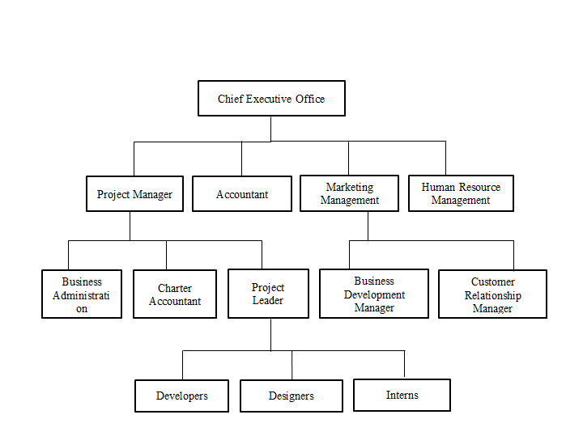

Figure 1:Next Step Organization Structure

## Working Domains of the Organization

As a IT company, Next Step likely operates in several working domain related to IT related works, including:

1. **Mobile App Development:** This domain involves the development of mobile applications for both IOS and Android platform. This may include using framework such as Flutter.
2. **Web Development and Visuals:** This domain involves the development of websites and web-based applications using languages such as JavaScript, HTML, and CSS. This also include the visuals and photography services.
3. **Graphic Designing and Animation:** This domain involves Graphic designing activities such as logo, banner designing, UI/UX designing poster designing and other type of designing using photoshop , coreldraw and adobe illustration.
4. **Digital sales and Marketing:** This domain involves in Digital marketing and branding of the various clients or organization and sales IT related products through online.

# 

## Description of intern Department/Unit

The internship period was 3 months, which was completed under the supervision of the allocated supervisor. Responsibilities were assigned to each individual according to the sprint. The actions were coordinated using priority and urgency. The highest- priority job is then selected first. As a Web app developer, the responsibilities included the following:

• Implementing responsive design principles to ensure the application works seamlessly across various devices and screen sizes.

• Integrating back-end functionality and database management to ensure smooth data flow and storage.

• Implementing features such as vehicle management, route optimization, transaction processing, and data synchronization.

• Ensuring data validation and integrity to prevent errors, inconsistencies.

• Working closely with back-end developers, database administrators, and other team members to integrate front-end and back-end components seamlessly

Collaborating with the development team to ensure the application is delivered on time and meets the project requirements.

• Using version control systems (e.g., Git) to manage code changes, collaborate with team members, and track project progress.

• Documenting the codebase, including comments, documentation files, and technical documentation, to ensure clarity for future development and maintenance.

• Staying updated with the latest web development trends, technologies, and best practices.

• Adapting to changing project requirements and incorporating feedback from team members .

• Analyzing complex technical challenges and finding innovative solutions to ensure the functionality, security, and performance of the web application.

• Keeping up to date with the latest trends and best practices in mobile app development and Flutter framework, and contributing to the development of technical documents or project reports

## Mission of Next Step

Mission: Some of the mission of the organization are:

• To approve the goal and prove to be the best by achieving the goals and objectives.

• To maintain strong relationship with their clients.

• To achieve the client’s goal by evaluating their resources and project

## Vision of Next Step

Vision: Some of the vision of the organization are:

• To make the company a systematic and qualitative company in IT sector

• To maintain organizational position in the market

• To develop the organization in more systematic way by using various tools and techniques

# Internship Activities

## Role and Responsibilities

During the internship period, I became acquainted with the organization's working culture and had the opportunity to apply my theoretical skills in a practical setting. The company's working environment was highly conducive, providing a professional learning experience that significantly contributed to the enhancement of my skills, knowledge, and ability to work effectively in a team. Collaborating with experienced professionals during this internship has boosted my confidence and contributed to my personal growth. Additionally, I acquired proficiency in the use of various tools and techniques, which proved invaluable in my professional development within the respective sector.

The following are all the activities and responsibilities that had been performed in the

internship period

**1. Create a Registration Form:**

Your first task is to design and develop a registration form. This form will likely collect essential information from users, such as their names, contact details, and other relevant data. The form should have a user-friendly interface and validation checks to ensure accurate data input.

**2. Implement CRUD Operations:**

CRUD stands for Create, Read, Update, and Delete. In the context of the Bagmati Tipper project, this likely means creating functionality to:

**Create:** You'll need to develop code that allows users to add new records or entries to the system. In this case, it could be adding information about new tippers or users.

**Read:** Implement the ability to retrieve and display data from the MySQL database. Users should be able to view existing records, such as registered tippers' details.

**Update:** Allow users to modify or update information already stored in the database. This might involve editing tippers' details if there are changes or corrections.

**Delete:** Provide a mechanism for users to remove records from the system, which could be relevant when tippers are no longer active or need to be removed from the database.

**3. Connect to MySQL Database:**

Your backend code needs to establish a connection with a MySQL database. You'll need to configure the database settings, create tables if necessary, and implement SQL queries to interact with the database. This includes inserting new records, retrieving data, updating existing records, and deleting records, as required for CRUD operations.

**4. Testing with Postman:**

Postman is a tool commonly used for testing APIs (Application Programming Interfaces). In your case, you'll use it to test the functionality of your backend API, including the registration form and CRUD operations. Postman allows you to send requests to your backend API, inspect the responses, and verify that everything works as expected. It's an essential tool for ensuring the reliability and functionality of your API endpoints.

**5. Use ngrok for Tunneling:**

Ngrok is a tool that creates secure tunnels to localhost. In the context of your project, you might use ngrok to expose your locally hosted backend API to the wider team or even external stakeholders. This is especially useful for collaborative development and testing when team members need access to your API for testing or feedback. Ngrok provides a temporary public URL that allows external parties to interact with your API without needing to be on the same local network.

**6. API Design:**

Collaborate with the team to design API endpoints and determine data structures for efficient data exchange.Define API routes, request and response formats, and authentication mechanisms.

**7. Data Serialization and Deserialization:**

Transform data between JSON formats and database objects as needed.

Handle serialization and deserialization of data for seamless communication with the frontend.

**8. Collaboration and Code Review:**

Participated in code review sessions, offering feedback to improve code quality. Collaborated with frontend developers to ensure consistent and effective communication.

## Weekly Log

**Week 1: Understanding and Designing**

Gained a comprehensive understanding of the Bagmati Tipper project's scope and objectives.

Collaborated with the team to establish the website design and functionality requirements.

**Week 2: Tool Study and Environment Setup**

Conducted an in-depth study of Java as the core programming language for the project.

Set up the development environment for Java, ensuring a conducive workspace for coding.

**Week 3: Spring Framework Exploration**

Explored the Spring Framework, focusing on its benefits for developing robust and scalable applications.

Studied the integration of Spring Boot to streamline application setup and configuration.

**Week 4: User Registration Model:**

A user registration model is crafted to represent the structure of user data. This model defines attributes, data types, and relationships necessary to accurately capture user information during registration. For instance, attributes might include username, email, password, and additional profile details.

**Week 5: Data Storage and Retrieval with Spring Boot**

Implemented Spring Boot to establish a foundation for data management.

Integrated a database solution to store user details securely.

**Week 6: User Interaction and Firebase Integration**

Developed user-friendly features, such as displaying recent activity and implementing search functionality.

Integrated Firebase authentication to ensure a secure and seamless user experience.

**Week 7 : Content Management and CRUD Functionality**

Added functionality for admin to create, read, update, and delete their posts.

Implemented best practices from Spring for efficient data handling.

**Week 8: Performance Optimization and Testing**

Dedicated efforts to optimizing the app's performance through code refinements.

Conducted thorough testing to identify and rectify any issues.

**Week 9: Maps Integration and Further Enhancements**

Integrated Google Maps API to enable users to view and manage locations.

Collaborated with the team to brainstorm additional enhancements for the project.

**Week 10: Final Testing and Presentation**

Undertook final testing to ensure the app's reliability, functionality, and user-friendliness.

Prepared a comprehensive presentation for the team, showcasing the app's key features and achievements.

Compiled a comprehensive project report, detailing the journey from design to implementation and lessons learned.

Throughout the ten-week project, Java served as the foundational programming language, driving the development of a feature-rich application. The utilization of the Spring Framework, along with Spring Boot, enabled efficient and organized coding practices. By seamlessly integrating Spring tools and Java, the Bagmati Tipper User Detail Management project successfully delivered an application that prioritized user experience, data integrity, and robust functionality.

Top of Form

## Description of the project involved during Internship

### Introduction to Project

During the internship, the primary project centered around developing a dynamic and efficient web application using the Spring MVC framework. The core focus was on incorporating JPA (Java Persistence API) for querying the database and utilizing various Spring annotations to enhance performance and ensure effective connectivity to the database.

### System Design

The system design of the project aimed to create a robust and efficient web application using the Spring MVC framework, enriched by the integration of JPA for seamless database connectivity. The design encompassed various architectural considerations, data flow patterns, and component interactions to ensure a cohesive and well-structured application.

**Component Breakdown:**

**1.Model Layer**: The model layer represented the application's data and business logic. It included entities annotated with ‘@Entity’ to map Java classes to database tables.

JPA entities incorporated attributes and annotations that defined relationships, constraints, and data types.

Repository classes, annotated with ‘@Repository’, handled interactions between the application and the database.

**2. View Layer:** The view layer focused on the presentation and user interface. Thymeleaf templates, integrated with Spring, dynamically generated HTML content.

Templates were responsible for rendering data from the model layer, ensuring a dynamic and responsive user interface.

**3. Controller Layer:** Controllers managed user interactions, processing requests, and generating responses. Annotated with ‘@Controller’, they orchestrated the flow of data between the view and model layers.

Request mappings, specified using annotations like ‘@RequestMapping’, directed incoming requests to appropriate controller methods.

### Tools and Technologies Used:

During the internship project, a combination of tools and technologies was employed to facilitate various aspects of development, testing, and deployment. Each tool played a unique role in enhancing productivity, collaboration, and the overall quality of the final product.

**1. Spring Tool Suite (STS):** Spring Tool Suite, an integrated development environment (IDE) based on Eclipse, was utilized for its robust capabilities in developing Spring-based applications. STS provided features like code assistance, project setup, and debugging, streamlining the development process within the Spring ecosystem.

**2. IntelliJ IDEA:** IntelliJ IDEA served as another primary integrated development environment, offering a rich set of features for Java development. Its intuitive interface, advanced code analysis, and efficient project management contributed to a seamless coding experience.

**3. Postman:** Postman emerged as an indispensable tool for testing APIs during the development process. Its user-friendly interface enabled the creation and execution of API requests, facilitating thorough testing and verification of endpoints and responses.

**4. Ngrok:** ngrok provided a secure tunnel to localhost, enabling the exposure of locally hosted applications to the internet. This tool was particularly useful for sharing development progress with teammates and stakeholders for remote testing and feedback.

**5. MySQL:** MySQL, a popular relational database management system, was employed for efficient data storage and retrieval. Its robust capabilities, ease of use, and integration with Spring and JPA allowed for the creation of a reliable and structured database backend.

Each of these tools and technologies contributed significantly to the development process, collectively ensuring efficient coding, comprehensive testing, and seamless database management. The strategic use of these tools enhanced the overall project quality and contributed to the successful creation of the Bagmati Tipper web application.

## Tasks/Activities Performed

Throughout the internship, a diverse range of tasks and activities were undertaken to develop and enhance the Bagmati Tipper project, utilizing the Spring MVC framework, JPA, and other relevant technologies. The following is an overview of the key tasks and activities performed during the internship:

**1. Requirement Analysis:**

Collaborated with team members to understand the project's scope and objectives.

Analyzed user requirements to determine the features and functionalities needed in the application.

**2. Environment Setup:**

Configured development environments using Spring Tool Suite (STS) and IntelliJ IDEA.

Integrated project repositories for version control and collaboration.

**3. Frontend and UI Enhancement:**

* **Enhanced User Interface with Bootstrap**
* Implemented Thymeleaf templates to dynamically render data on the frontend.

**4. Backend Development:**

Developed backend components using Spring MVC, creating controllers, services, and repositories.

Integrated JPA to perform data operations, ensuring efficient database connectivity.

**5. User Registration and Authentication:**

* Implemented user registration functionalities, including data validation and encryption of sensitive information.
* Integrated Spring Security to ensure secure user authentication and access control.

**6. User Profile Management:**

* Created the user profile page, enabling users to manage and personalize their information.
* Implemented logic for users to upload profile pictures and manage personal data.

**7. REST APIs and Postman Testing:**

* Designed and implemented REST APIs to expose application functionalities.
* Utilized Postman to test API endpoints, ensuring their accuracy and responsiveness.

**8. Database Integration and JPA:**

Integrated MySQL database with the application using JPA's EntityManager.

Defined JPA entities and mapped them to database tables for seamless data interaction.

**9. Data Retrieval and Manipulation:**

* Implemented JPA queries to retrieve specific data from the database.
* Developed code for creating, updating, and deleting records in the database.

**10. Testing and Debugging:**

* Conducted thorough testing of both frontend and backend functionalities.
* Debugged and resolved issues to ensure smooth application behavior.

**11. Collaboration and Code Review:**

* Participated in code review sessions, offering feedback to improve code quality.
* Collaborated with frontend developers to ensure consistent and effective communication.

**12. Documentation and Reporting:**

* Documented project progress, codebase explanations, and implementation details.
* Prepared project reports summarizing tasks, challenges, and outcomes.

**13. Ngrok and Remote Testing:**

Utilized ngrok to expose locally hosted applications for remote testing and feedback.

**14. Presentation and Final Report:**

* Presented the developed application to team members, showcasing its features and functionalities.
* Compiled a comprehensive final project report, highlighting the journey, achievements, and lessons learned.

Throughout these tasks and activities, a combination of Spring MVC, JPA, MySQL, and other tools contributed to the successful development of the Bagmati Tipper application. The internship experience encompassed a holistic approach to software development, from concept to implementation, testing, and documentation.

Top of Form

# Conclusion

## Conclusion

All in all, during the internship program the author was able to gain the insights onto the IT industry and the real-world working environment. The knowledge gained throughout the four years of the academia has been fruitful during this internship period for the author. The author considered it as the golden opportunity to be able to get exposed to the IT industry and the author is forever grateful to have been able to work at such a reputed company.

Working at Next Step, provides me a great opportunity to enhance knowledge and skill that I have learnt in college. I got a chance to involve in a real-world task and most importantly work in team. Internship is a formal program that is performed within an organization whose primary goal is to offer practical work experience in a particular task to people who are totally new in that field. Internship program provides opportunity to understand the industry and know how the work is actually done.

## Learning Outcomes

Participating in the Bagmati Tipper project yielded several key learning outcomes in Java:

**Java Fundamentals:** Mastered Java's syntax, data structures, and core principles.

**Object-Oriented Programming (OOP):** Applied encapsulation, inheritance, and polymorphism for structured code.

**Framework Proficiency:** Utilized Spring MVC,ORM ,Hibernet, JPA for efficient web application development and other programming.

**Database Interaction:** Gained skills in JDBC for seamless database operations.

**Error Handling and Debugging:** Enhanced problem-solving abilities through real-world challenges.

**Collaborative Development:** Learned effective teamwork and Git version control.

**API Integration:** Successfully incorporated external APIs for expanded functionality.

**Continuous Learning Mindset:** Embraced ongoing improvement and adaptation.

**Real-World Application:** Applied theoretical knowledge in developing functional applications.

References

baeldung. (Last updated: June 18, 2023). *JPA*. Retrieved from Get started with Spring Data JPA through the reference Learn Spring Data JPA course: https://www.baeldung.com/learn-jpa-hibernate

baeldung. (Last updated: June 30, 2023). *Get started with Spring 5 and Spring Boot 2, through the Learn Spring course:*. Retrieved from Spring Boot: https://www.baeldung.com/spring-boot

*Javatpoint Logo*. (n.d.). Retrieved from Spring Tutorial: https://www.javatpoint.com/spring-tutorial

# Appendix



Figure 2: : Swing Demo Project of Bank Loader

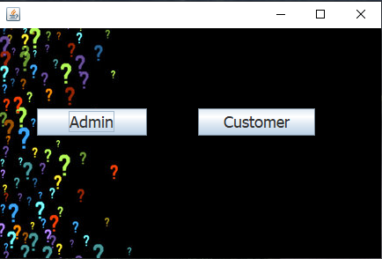

Figure 3: : Swing Demo Project of Bank Dashboard

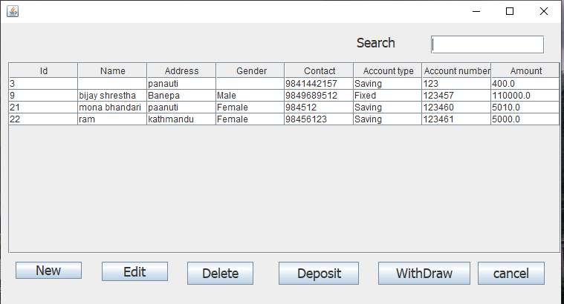

Figure 4: Swing Demo Project of Customer Details

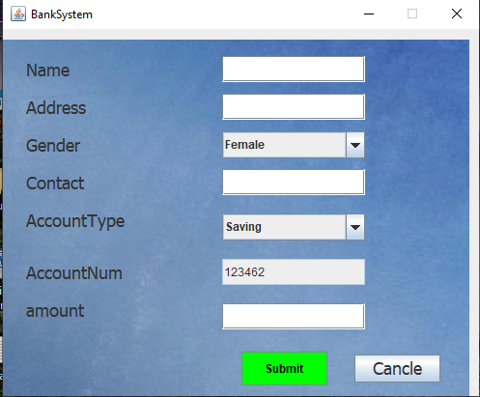

Figure 5: Swing Demo Project of Registration

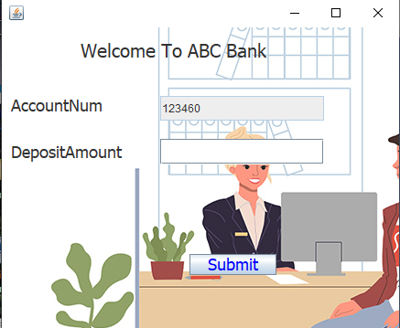

Figure 6: : Swing Demo Project of Deposit Amount



Figure 7: Bagmati Tipper Dashboard

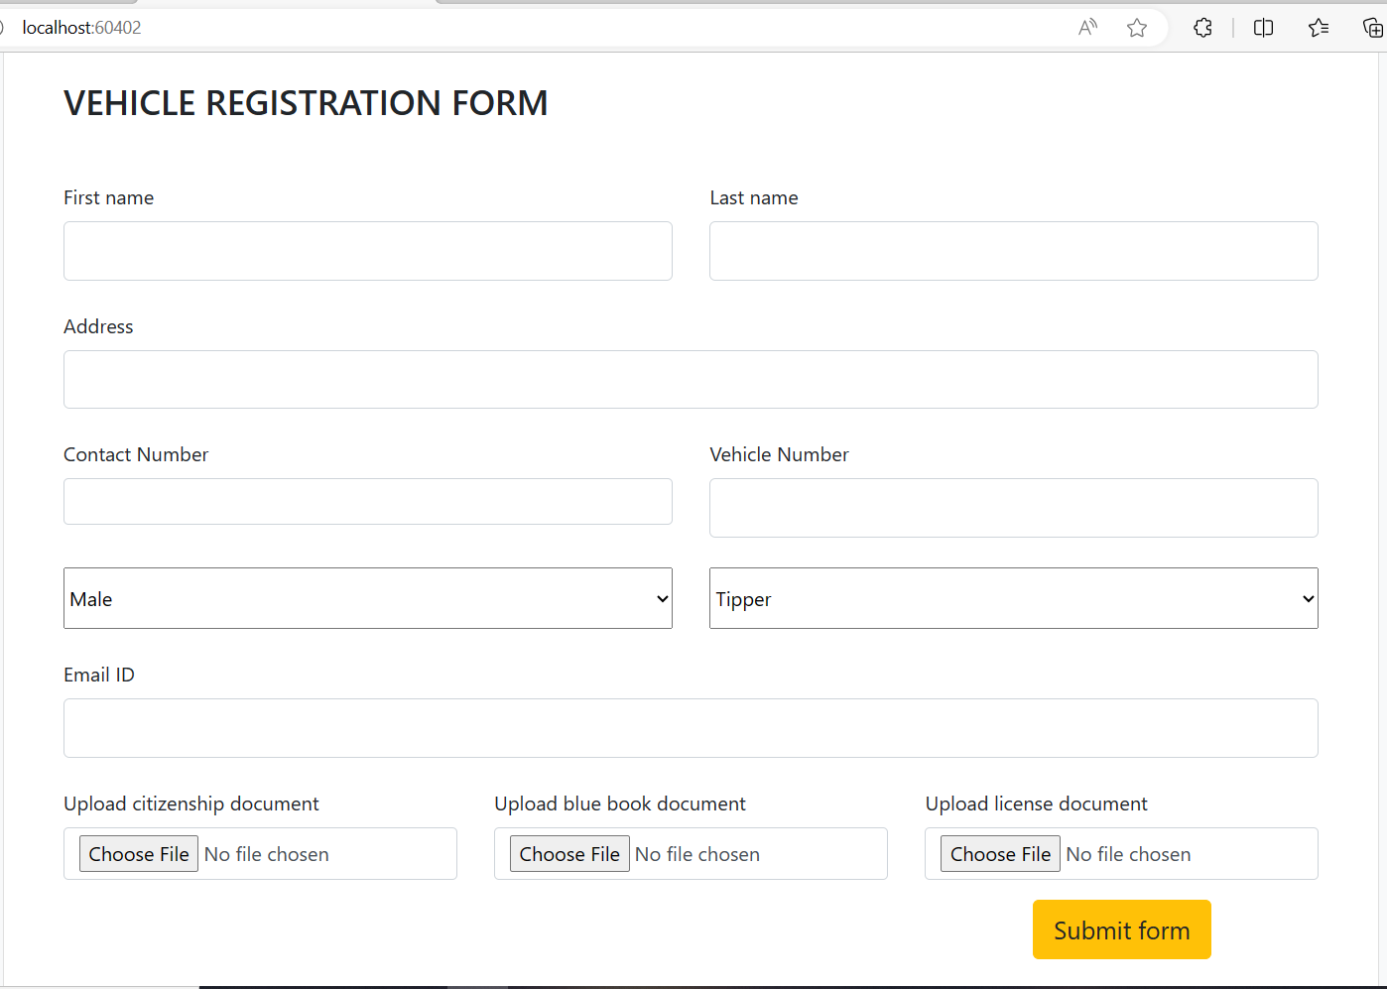

Figure 8:Vehicle Registration Form

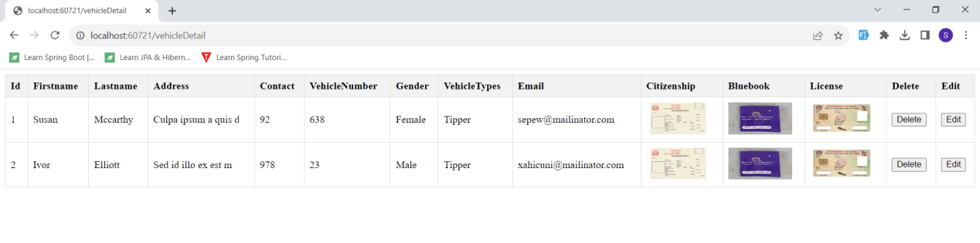

Figure 9**:** VehicleDetails

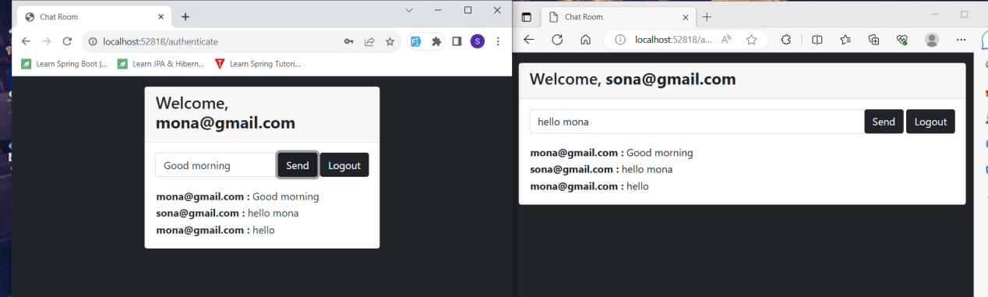

Figure 10: ChatBox

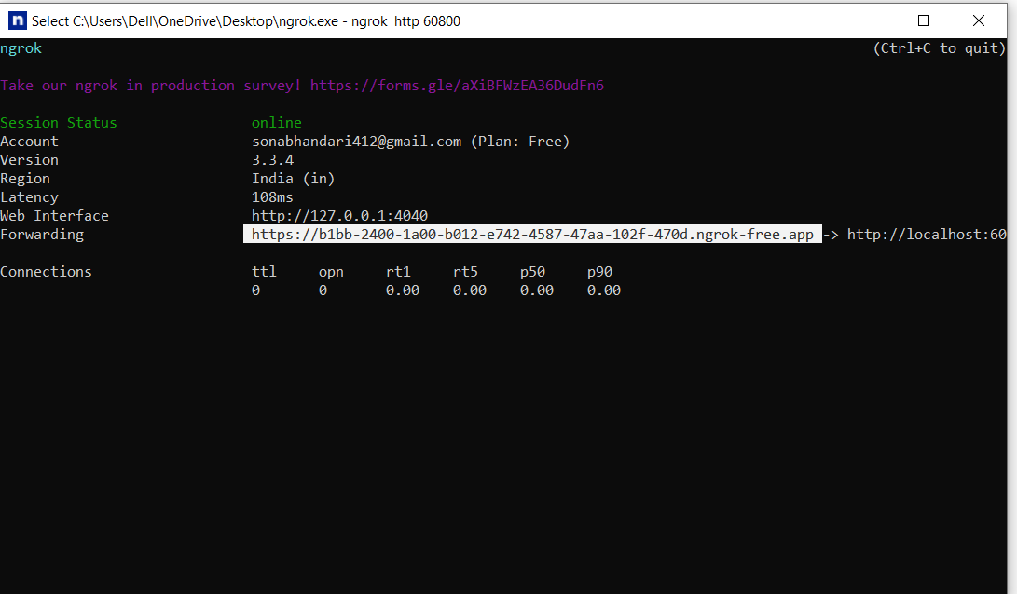

Figure 11**:** Ngrok

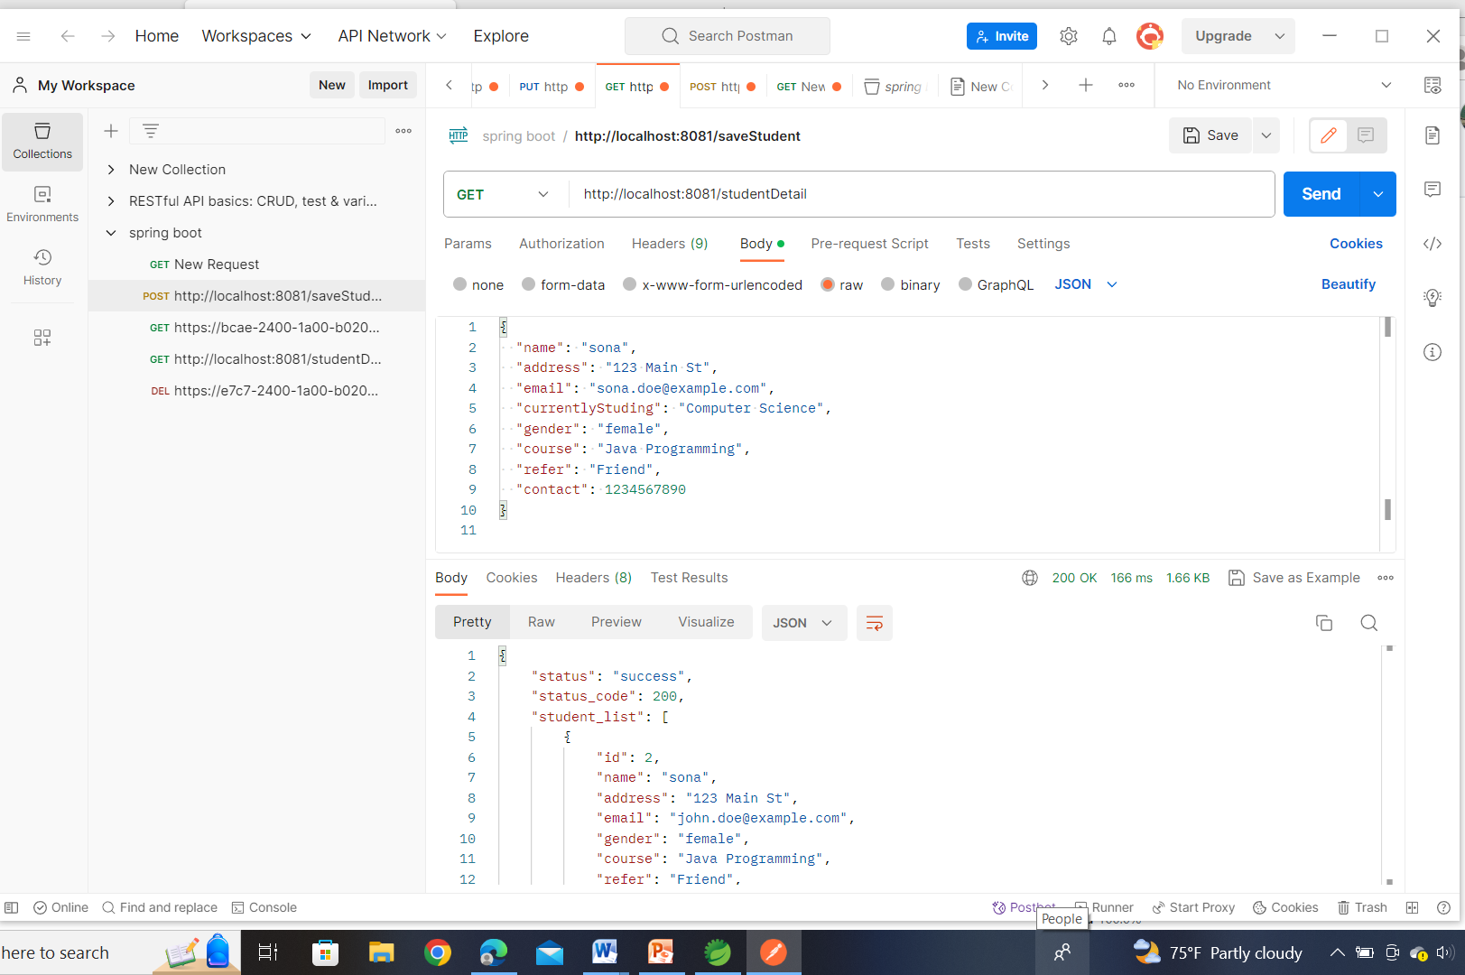

Figure 12: Postman(GET)

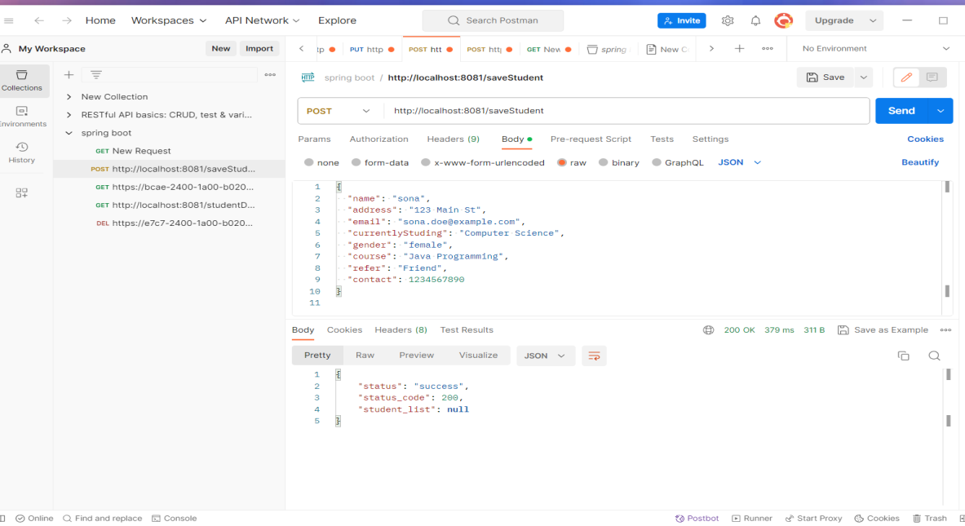

Figure 13: Postman(POST)

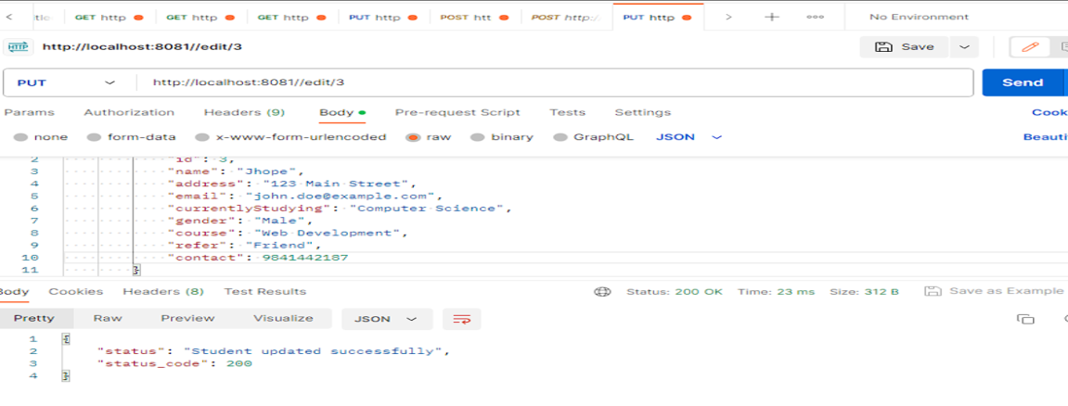

Figure 14: Postman(PUT)

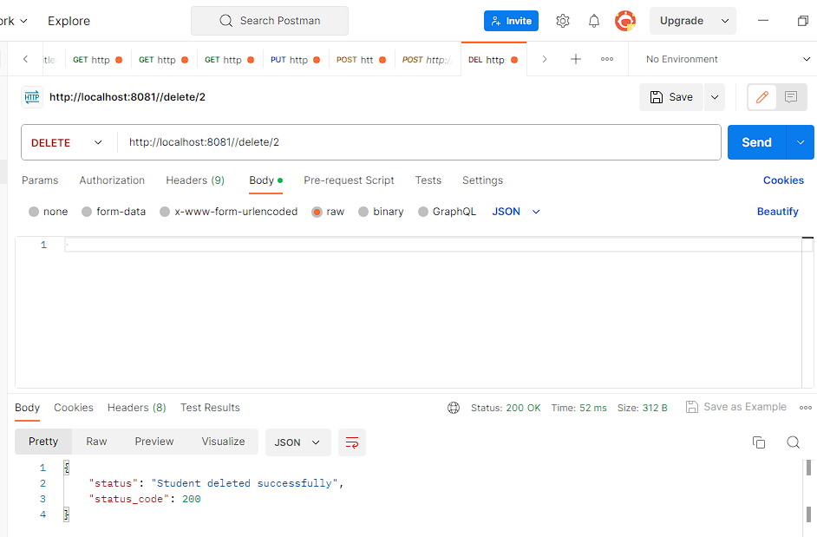

Figure 15: Postman(DELETE)

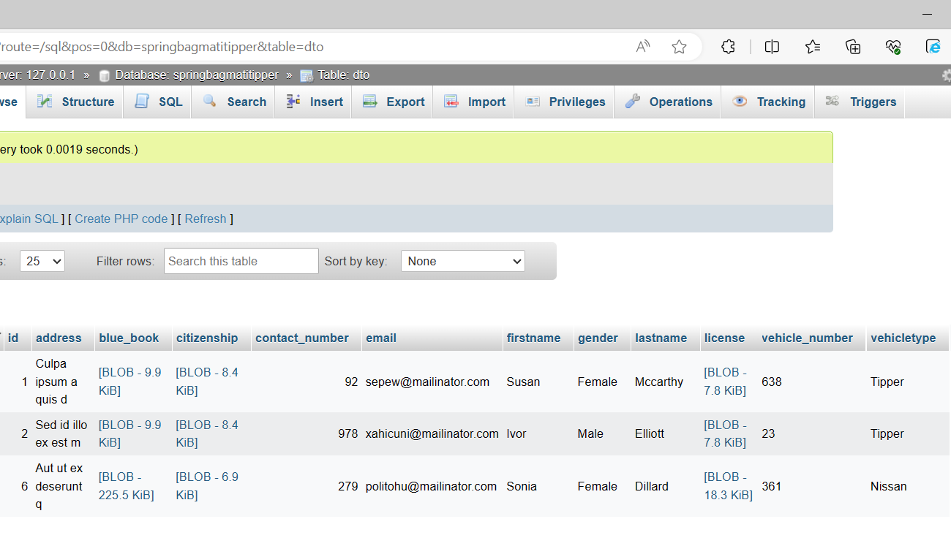

Figure 16: Vehicle Registration Database